Term 1 Game Development

I missed out on doing Flappy bird Since I kept needing more storage and unity was being difficult however I was able to start Sprite Flight starting later than others.
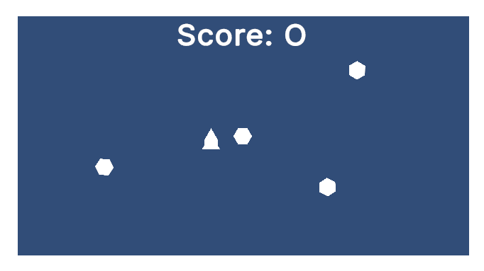
The sprite flight game went well; I could not finish it, but I had fun solving issues with my code, unity is still very hard to use since I’m not used to its layout, and I don’t fully understand how it works yet

I was also able to make most of the Delivery driver game. The video was a bit harder to follow since you have to actively listen but overall the experience was around the same.
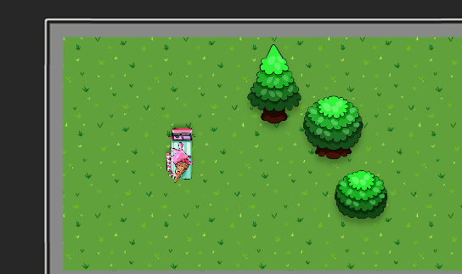
Overall The tasks so far have been very nice and the games we had to make where not boring and I was able to learn and be a lot better at coding on unity since I have never used something like it besides Scratch.

